PASTE HERE LATEST SELF-ATTESTED COLOR

PHOTOGRAPH AGAINST WHITE BACKGROUND

**APPLICATION FORM**

|  |  |
| --- | --- |
| **Personal details** | |
| NEET UG Roll number: |  |
| NEET UG Application number: |  |
| All India NEET UG Rank: |  |
| Candidate name |  |
| Father name |  |
| Mother name |  |
| Gender |  |
| DOB |  |
| Nationality |  |
| Religion |  |
| AADHAR No: |  |

1. Category against which the seat is applied for

**(Tick only Advertised category)**

|  |  |  |  |  |
| --- | --- | --- | --- | --- |
| **UR** | **OBC**  **(Non-Creamy)** | **SC** | **ST** | **EWS** |
|  |  |  |  |  |

1. Whether candidate belong to: (Tick against the category)

|  |  |  |  |  |
| --- | --- | --- | --- | --- |
| **UR** | **OBC**  **(Non-Creamy)** | **SC** | **ST** | **EWS** |
|  |  |  |  |  |

1. Person with disability: Yes/No
   1. Correspondence Address:

PIN

Tel. No.

Mobile No.

Alternate Mobile No.

E-mail ID:

* 1. Permanent Address:

PIN

Tel. No.

Mobile No.

Alternate Mobile No.

E-mail ID:

1. **Educational Qualifications:**

|  |  |  |  |  |  |
| --- | --- | --- | --- | --- | --- |
| **Examination Passed** | **Year of Passing** | **No. of attempts** | **Marks obtained out of Total**  **marks** | **% of marks**  **/Division** | **University**  **/ Institution** |
| **Matric /S.S.C.** |  |  |  |  |  |
| **Intermediate**  **/HSC** |  |  |  |  |  |
| **Any other** |  |  |  |  |  |

|  |  |  |  |
| --- | --- | --- | --- |
| **Intermediate or 12 th exam** | **Total marks** | **Marks obtained** | **% of marks**  **/Division** |
| **English** |  |  |  |
| **Biology** |  |  |  |
| **Physics** |  |  |  |
| **Chemistry** |  |  |  |

**Payment details to be filled by all Applicants:**

|  |  |  |  |  |
| --- | --- | --- | --- | --- |
| **Issuing Bank & Branch** | **Transaction/Reference No.** | **Mode of Payment**  **(UPI/NEFT/IMP**  **S/etc)** | **Amount Paid** | **Date of issue** |
|  |  |  |  |  |

**Declaration:**

I hereby declare that the above information is true, complete, and correct to the best of my knowledge and belief. Any mistake/misinformation, detected at the time of admission or at any stage in future, will result in the cancellation of admission. I have read the prospectus and understood all the procedure

Date: Signature of the candidate:

Place:

**Certificates to be enclosed:**

1. 10th Mark sheet
2. 10th Passing certificate
3. 12th Mark sheet
4. 12th Passing certificate
5. Caste Certificate (For reserved category)

Govt. of India Format attached (in case of SC/ST/OBC/EWS Candidates). The Caste/ Category certificate should be issued by a competent authority for admission in Central Govt. College/Institute. The OBC certificate issued from 24/08/2023 to 24/08/2024 and for EWS certificate issued from 01/04/2024 to 24/08/2024 will be considered valid as the starting of reporting of Round-1 of MBBS counseling (24/08/2024) schedule as notified by (Medical Counselling Committee for MBBS admission). The sub-caste should tally with the central list of OBC. Community of SC/ST should be clearly mentioned

**(Annexure I -OBC, Annexure II-SC/ST, Annexure III-EWS)**

**OBC(NCL)/EWS certificate should be valid for Central Government jobs/Central Govt.**

**Institutions only, otherwise claim for OBC (NCL)/EWS reservation will not be considered.**

**Issuing date of OBC (NCL)/ EWS Certificate should be as follows:**

|  |  |  |
| --- | --- | --- |
| **S.No.** | **Category** | **Date of Issue** |
| **1** | OBC (NCL) | 24/08/2023 to 24/08/2024  (Both dates inclusive) |
| **2** | EWS | 01/04/2024 to 24/08/2024  (Both dates inclusive) |

1. Migration certificate issued by the board
2. Character Certificate
3. Demand draft/ NEFT- (If applicable)

(Proof of payment for application form)

**ANNEXURE-I**

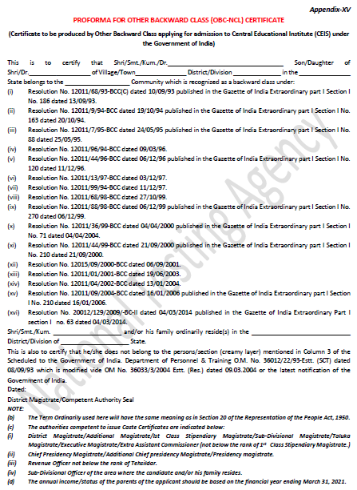

**ANNEXURE-II**

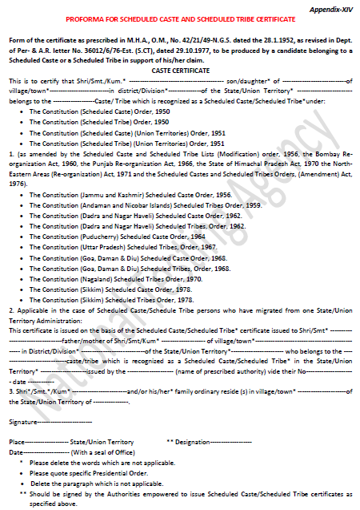

**ANNEXURE-III**

**PROFORMA FOR EWS CERTIFICATE**

**Government of (Name &Address of the authority issuing the certificate)**

**INCOME& ASSETS CERTIFICATE TO BE PRODUCED BY ECONOMICALLY WEAKER SECTIONS**

Certificate No.……………….. Date: ……………..

VALID FOR THE YEAR……………

This is to certify that Shri/Smt./Kumari…………………………………………...son/daughter/wife of………………

Permanent resident of……………………………village/Street……………………….Post office…………………

District……………………in the State/Union Territory…………………Pin Code whose

photograph is attested below belongs to Economically Weaker Sections, since the gross annual income* of his/her family** is below Rs.8 lakh (Rupees Eight Lakh only) for the financial year………………………… .

His/her family does not own or possess any of the following assets***:

* + 1. 5acres of agricultural land and above;
    2. Residential flat of 1000sq. ft. and above;
    3. Residential plot of 100sq. yards and above in notified municipalities;
    4. Residential plot of 200sq. yards and above in. are as other than the notified municipalities.

Shri/Smt./Kumari……………………………………belongs to the caste which is not

Recognized as a Scheduled Caste, Scheduled Tribe and Other Backward Classes (Central List).

Signature with seal of Office: …………….

Name:………………………………….

Designation:……………………………

Recent Passport size attested photograph of the candidate

**\*Note: Income covered all sources i.e. salary, agriculture, business, profession etc.**

**\*\*Note2: The term’Family"forthis purpose include the person, who seeks benefit of reservation, his/her parents and siblings below the age of 18years as also his/her spouse and children below the age of I8 years**

**\*\*\*Note 3: The property held by a "Family' in different locations or different places/cities have been clubbed while applying the land or property holding test to determine EWS status.**