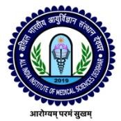
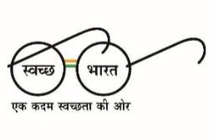
ALL INDIA INSTITUTE OF MEDICAL SCIENCES DEOGHAR
(स्वास्थ्य एवं परिवार कल्याण मंत्रालय, भारत सरकार के अधीन राष्ट्रीय महत्व संस्थान)
(An Institution of National Importance under Ministry of Health & Family Welfare)
भारत सरकार/ Government of India
Department of PMR

AIIMS/Deo/PMR/2023-24/179 Date: 09/02/2024

This is the provisional result for the post of Project Technical Support - III & Project Technical Support – I with approved by competent authority.

Title of the study:-“Assessment of unmet needs and access to assistive technologies among the general population through the digital rATA tool: A cross- sectional survey in India”.
PI- (Prof.) Dr. Saurabh Varshney
(CO-PI) – Dr Deepak Kumar, Nodal Officer, Department of PMR.
Based on document verification and assessment of the selection committee for the interview conducted on 22/01/2024 at AIIMS Deoghar, the result is as follows:
Project Technical Support- I
1. | SUKESH KUMAR | Selected
2. | KUNDAN KUMAR | Selected
3. | SUTAPA PAL | Selected
Project Technical Support- III
1. | KHAGESHWAR KUMAR | Selected
2. | MD IMRAN | WL-1
3. | TARIQUE AZIZ ANSARI | WL-2

Selected candidate will be intimated through e-mail and appointment letter will be sent to the registered email ID.

Dr Deepak Kumar
Associate Professor
Department of PMR
AIIMS, Deoghar
(CO-Principal Investigator-ICMR)

