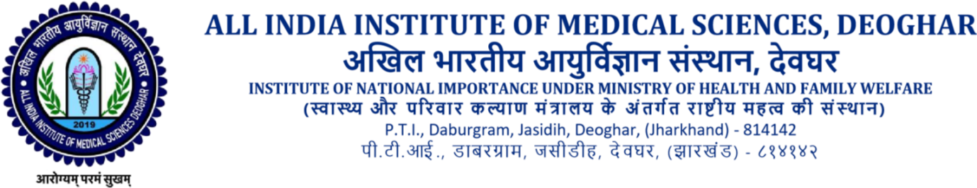

CRITICAL DATE CORRIGENDUM
AIIMS/DEO/LAUNDRY/2022-23/09
Following are the changes on Critical Datesfor Laundry Services Tender. All the bidders are requested to refer the Corrigendum as below:

S.No. | Existing Date | Revised Date/Corrigendum Date
1. | Bid Submission End Date  16/08/2023, 05:00 PM | Bid Submission End Date  23/08/2023 , 05:00 PM
2. | Bid Opening Date  17/08/2023, 05:00 PM | Bid Submission End Date  24/08/2023 , 05:00 PM

For & on behalf of
Executive Director
AIIMS, Deoghar
Faculty in Charge Tender

