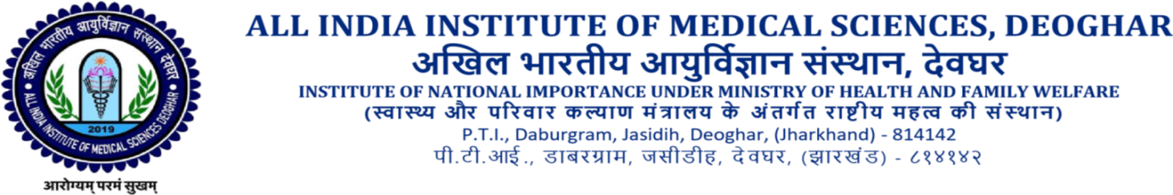
TECHNICAL CORRIGENDUM
Matter Is Regarding for Laundry Services Tender No. AIIMS/DEO/LAUNDRY/2022-23/09 In which Following Modification Has Been Approved By Competent Authority:-

S.No. | Tender Clause | Modification
1. | Page No. 14 ( Drying Tumbler 01)  Clause (m)  DoorOpening-900mmØ(Minimum)  Clause (n)  BasketVolume-1200Ltrs.(Minimum) | Door opening should be 800 to 900 mm  Rest of the specification as per tender document
2. | Page no 8  Scope of work Point no 3  The Rate must be inclusive of the cost of linen. | AIIMS Deoghar will provide the linen. Therefore, rate must not include the cost of linen.

For & on behalf of
Executive Director
AIIMS, Deoghar
Faculty in Charge Tender

